## Activities

1. Draw a Context Diagram based on the meeting transcript in Exhibit 2 of the overview plus the use-case (event/response) matrix you prepared for Assignment 1. Note that not everything in the transcript is related to the Context Diagram.

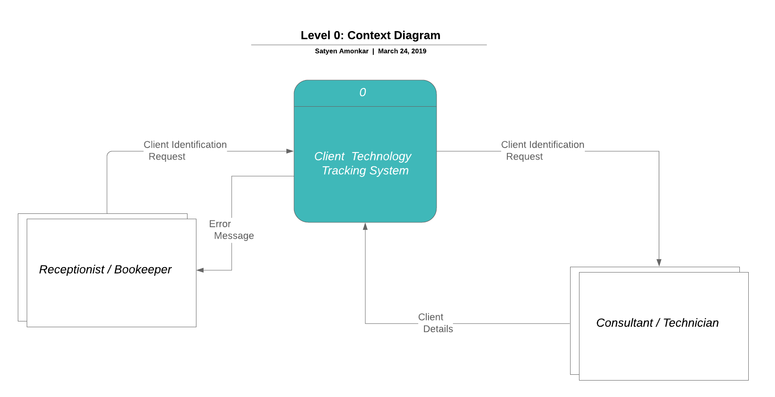

1. Draw a System Diagram (i.e., the Level 1 diagram).

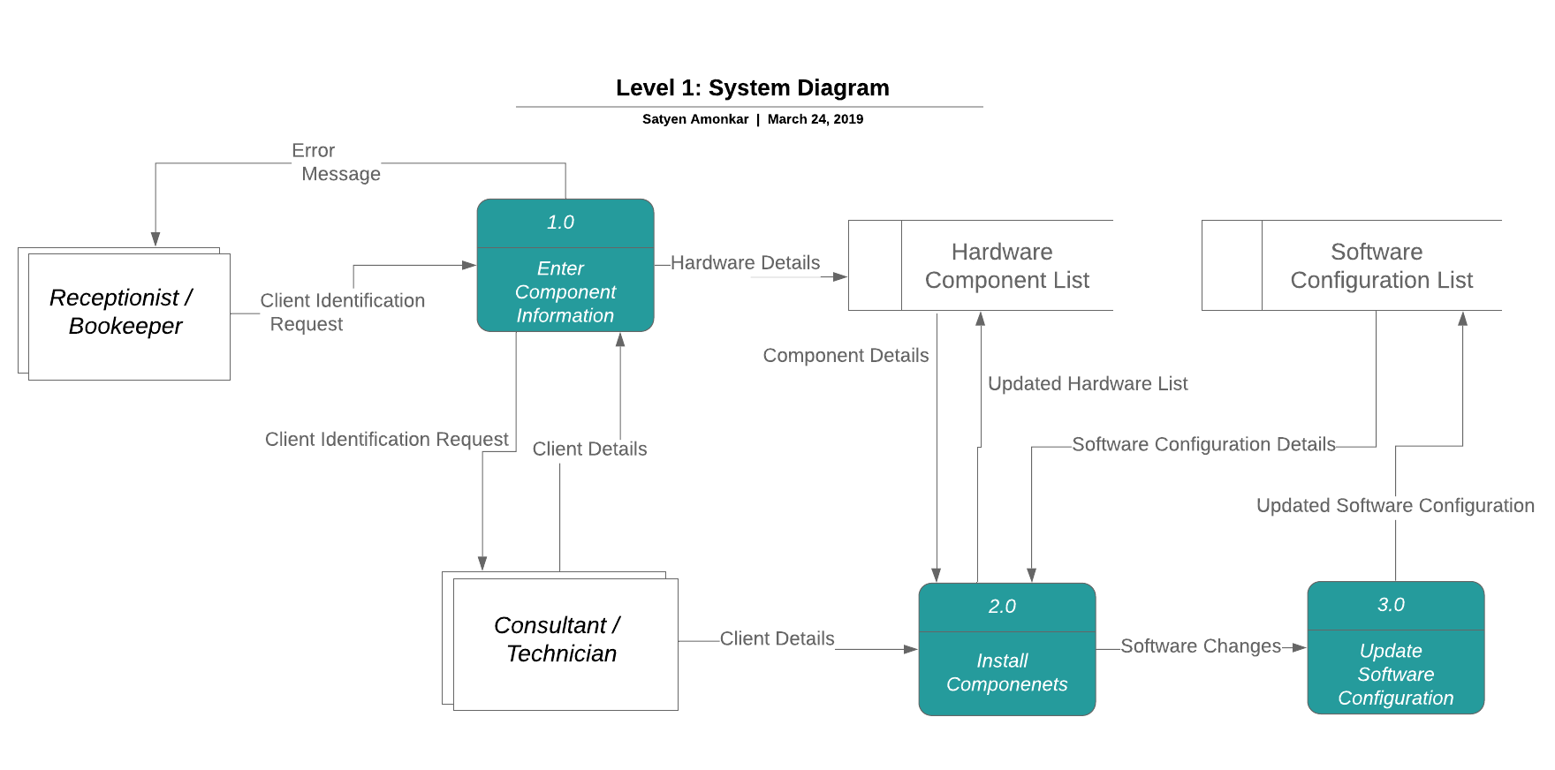

1. For the transaction processes described in the accompanying narrative (Exhibit 1), draw the Primitive Data Flow Diagram (i.e., the Level 2 diagrams).

**Primitive Diagram for the Enter Component Information event**

